Currently there’re V1 and V2 control protocol.
V1 used for single control, as one command can only control one parameter.
V2 mainly used for controlling continuous multiple channels.

Byte1 | Byte2 | Byte3 | Byte4 | Byte5~12
0xb3 | Message Type | 0x00 | 0x00 | Data

V1, message type includes 0x21 (Parameter control), 0x22 (Parameter acquisition), 0x13(Scenario switch),

{Here is related to question 1 in your email, will need to send command 0x22 message type to get data/status for specific channel.}

Here is an example, Q: if I want to send MUTE to input channel 2, I can´t see how it gets to this string below following the manual:

B3 21 04 00 2B 01 02 00 01 00 01 00

I get this from the “center control command” feature in the SW. Sending it works as well but I can´t see how to get this string following the instructions in the manual.

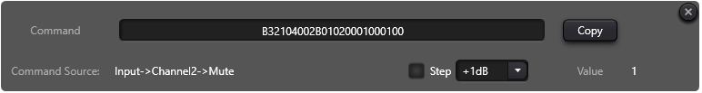

Explanations:

B1 = B3 (start of command) L: This is fixed. (Always starts with B3)
B2 = 21 (set command) L: "21" represents parameters control, "22" obtain parameters, "13" scenario switch
B3 = 04 Length? How do I get this value L: This is generated randomly, no real meaning.
B4 = 00 Version? In this case it is 00? L: "00" represents V1, "01" represents V2. As described in manual, V1 used for one command control one parameter, while V2 is recommended to use for one command to control continous multiple channels.
B5 = Data ( This I can understand using little endian hex etc) L: This is related with Byte 5~12
Byte 5~6, 2B 01, this is Module ID 299 in Hex (299 in Hex should be 12B, but hundreds digit "1" in Byte 6, while tens and units digital in Byte 5)

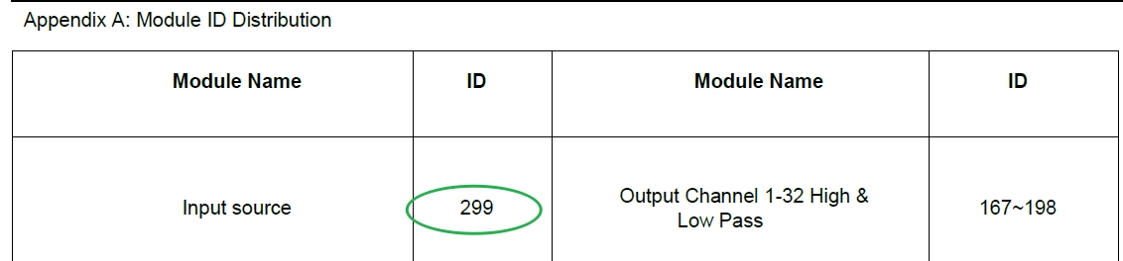
Byte 7~8, 02 00, refer to Appendix B
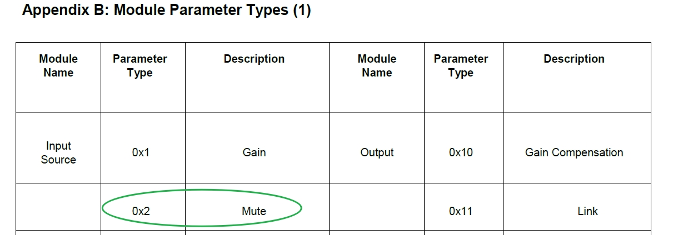

Byte 9~10, 01 00, represents input channel 2; If channel 3, then should be 02, 00
Byte 11~12, 01 00, represents mute on, 00 00 means mute off..
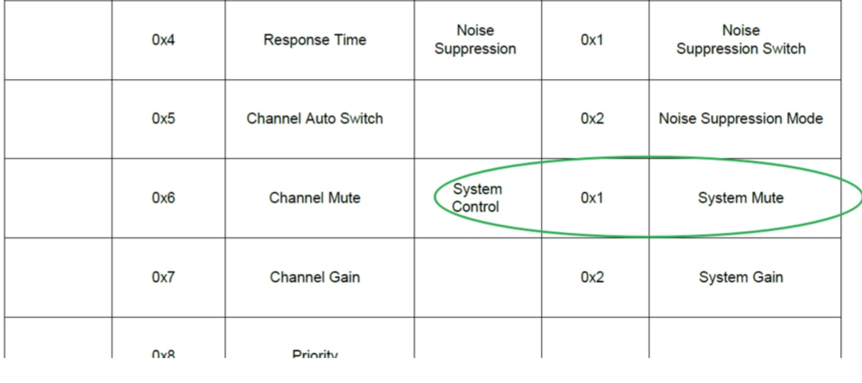

V2, There’re more message type, which includes 0x21 (Parameter control), 0x22 (Parameter Acquisition), 0x13(Scenario Switch), 0x74 (Other controls) and 0x6e (Dante routing).

Byte1 | Byte2 | Byte3 | Byte4 | Byte5~12
0xb3 | Message Type | 0x00 | 0x01 | Data

Byte5 | Byte6 | Byte7 | Byte8 | Byte9~72
Input/Output | Start Channel | End Channel | Parameter Type | Data

For parameters control and acquisition:

Byte5, 0x02- represents input channel while 0x01- represents output channel
Byte6, Start channel, starts from 0 (channel 1)
Byte7, End channel.
Byte 8, Same as V1 definition.
Byte 9~ 72, no specified length, every channel takes 2 bytes.

e.g. :

To acquire input channel 2~6 level value, codes should be
b3220a010201050c00000000000000000000

Explanation:
B3 - Fixed,
22- Message type (Acquisition)
0a - Length, no real meaning
01 – V2 version
02(Byte5) – input channel
01(Byte6) – Start input channel, 01 represent channel 2
05(Byte7) – End input channel, 05 represent channel 6
0c(Byte8) – Level value
0000 – to acquire just insert 0000 at least 0000

Response:
B3220A010201050C40ED5AF179EC96ECEEEC

Here we got data for channel 2~6, every channel has 2 bytes, let’s take EEEC(Input 6) as calculation.
User windows calculator, insert ECEE to get -4882, divided by 100, then value is -48.82
Level value is dbfs, maximum is 0

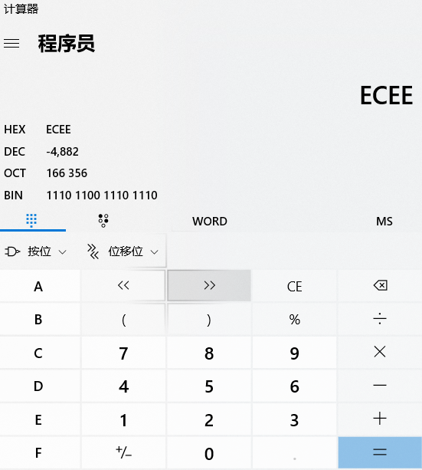
R&D offered bottom design codes (python as an example), please have a look.

def sun (highbyte,lowbyte):
level = highbyte * 256 + lowbyte
if level > 32767:
level = level - 65536
return level/100

level_decimal=sun(0xec,0xee)

